**Understanding Percent**

November 5, 2018

Anne McCannel, Instructor

Percent (%) is a way of expressing units in parts per hundred.

In food technology, we sometimes express percent as weight per weight (w/w), weight per volume (w/v), or volume per volume (v/v). In addition, on Nutrition Facts tables, some nutrients are expressed in % daily value.

Percent (weight/weight)

When we measure the amount of protein in flour, we determine the weight of the protein found in a specific weight of flour. This can then be expressed as % (w/w).

For example, assume we find 0.348 grams protein in 3.000 g flour. This can be expressed as 11.6% (w/w) protein. Another way to think of this is there is 11.6 g protein in 100 g flour.

Percent (volume/volume)

You might be asked to make a solution for a chemical analysis that is based on % (v/v).

For example, to make a 1% (v/v) solution, you could take 1 mL and dilute it up to 100 mL.

Percent (weight/volume)

When we measure the amount of protein in milk, we determine the weight of the protein found in a specific weight of milk (expressed as % (w/w), or a specific volume of milk (expressed as % (w/v).

For example, assume we find there is 0.163 grams protein in 5.00 mL milk. This can be expressed as 3.26% (w/v) protein. Another way to think of this is there is 3.26 g protein in 100 mL of milk.

% Daily Value is calculated based on the daily value. The daily value is either the amount recommended for the day, or a reference standard that has been established for a day.

% DV = (amount of a nutrient in a serving size / daily value) x 100%

Importance of understanding percent

Nutrition facts tables are always based on the serving size of the product. The serving size may be in grams (for solid products), or in mL (for liquid products). Food Technologists need to be able to readily convert % values to serving size amounts, and serving size amounts back to %.

As an example, see the Nutrition Facts from a Dairyland Sour Cream product on the next page.

The label shows that there is 4.5 g fat in 30 mL sample. This is equivalent to 15% fat.

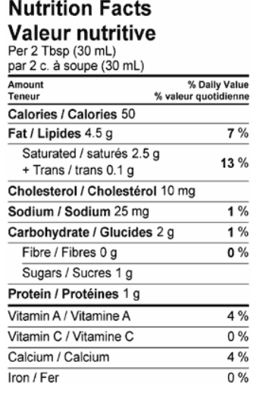

Source: Dairyland website. <http://www.dairyland.ca/en/products/sour-cream/sour-cream>. Accessed November 5, 2018.